TIAN EN ACADEMY

MATHEMATICS UNIT TEST

STATISTICS

NAME: ______

SCORE: _______

1. Table

   Description automatically generated
2. Graphical user interface, text, application

   Description automatically generated
3. 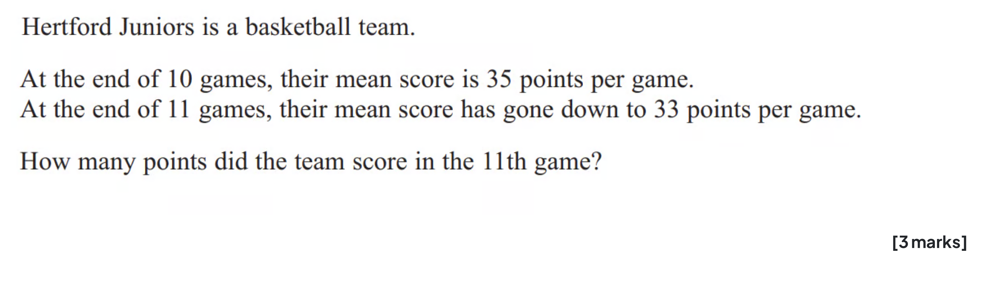
4. Chart, table

   Description automatically generated

(a)  
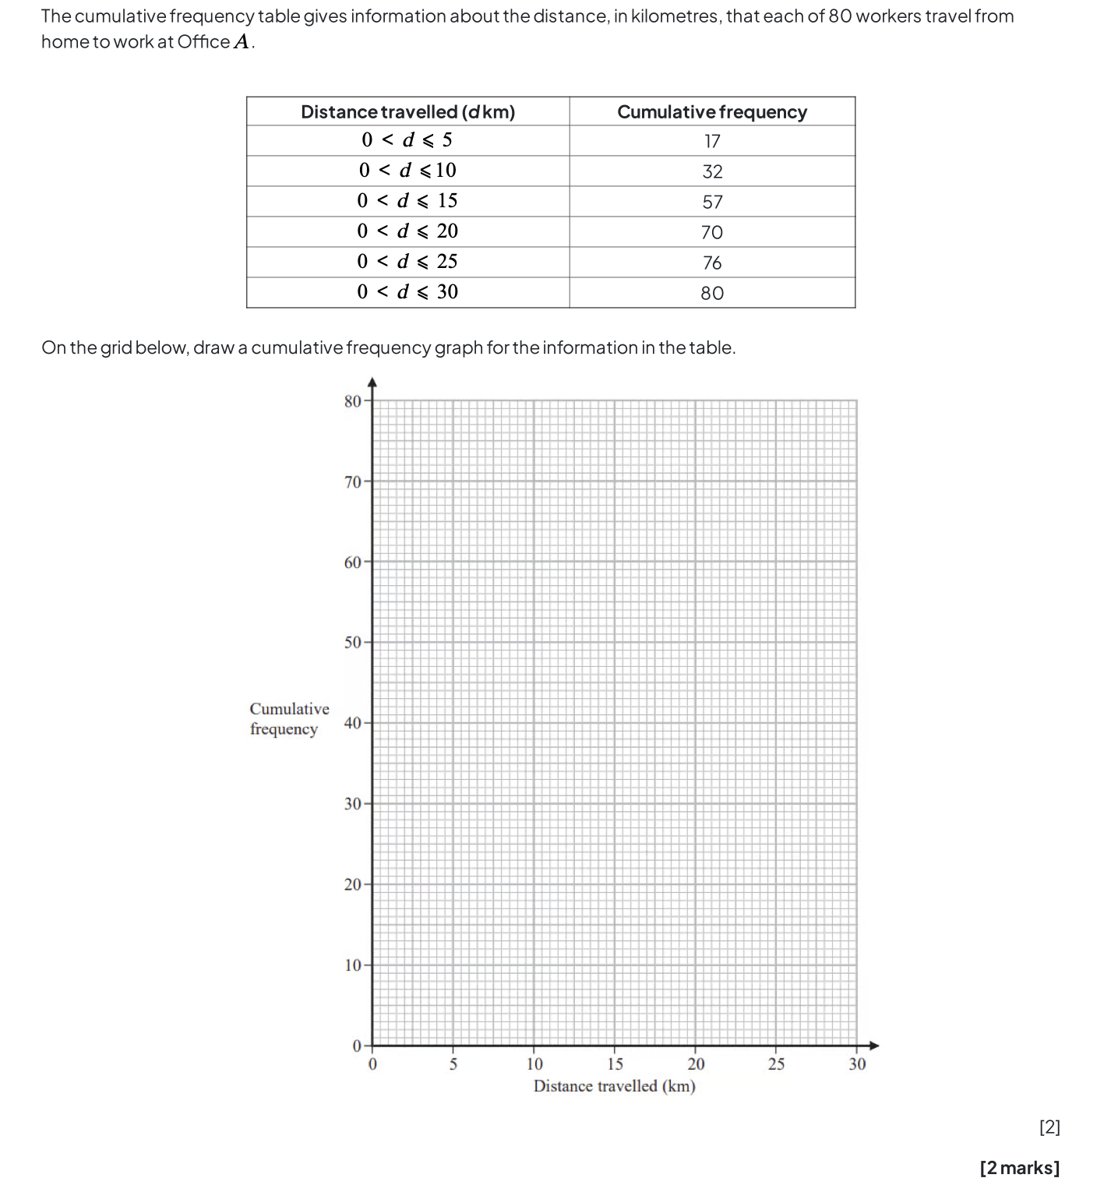

(b)

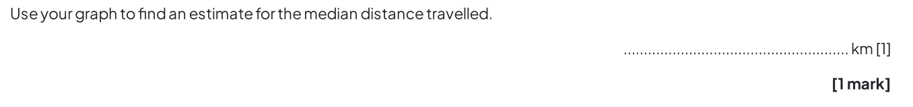

(c)

7.

8.

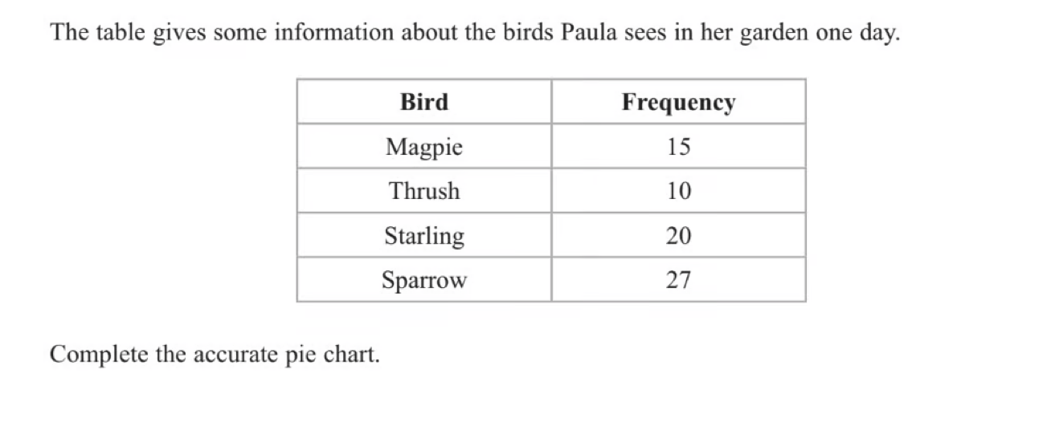

10.

(a)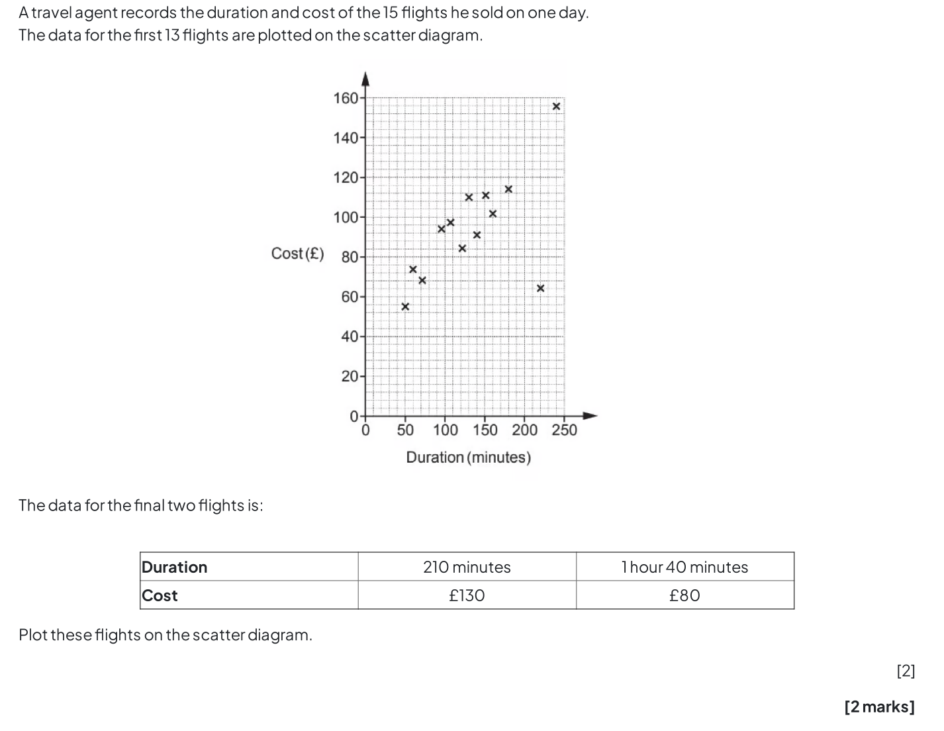

(b)

(c)

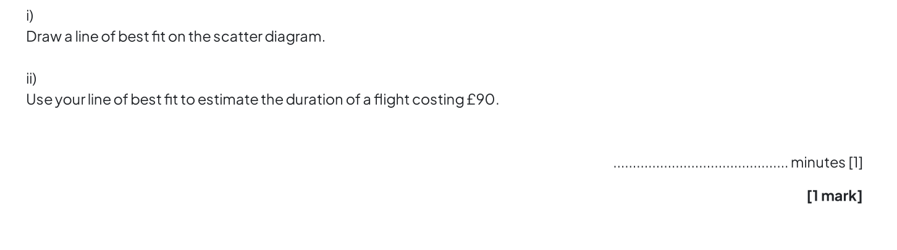

(d)

